**Date 28/2/2025 EXPERIMENT-15**

# DESIGN THE NETWORK MODEL FOR SUBNETTING – CLASS C ADDRESSING USING PACKET TRACER

**AIM:** To design the network model for subnetting-class C addressing using packet tracer.

**Software/Apparatus required:** Packet Tracer/End devices, Hubs, connectors.

**Algorithm:**

1. Determine the network requirements: Identify the number of subnets and hosts required for each subnet.
2. Choose a subnet mask: Select a subnet mask that can accommodate the required number of subnets and hosts.
3. Calculate the subnet mask and prefix length: Use the formula 2^p - 2 >= n, where p is the number of host bits and n is the required number of hosts per subnet, to calculate the number of host bits required. Add these host bits to the Class C network address to create the subnet address. The remaining bits in the subnet mask will be the prefix length.
4. Configure the router: Configure the router interface with the subnet address and subnet mask.
5. Configure the hosts: Configure each host with an IP address and subnet mask that matches the subnet address and subnet mask used on the router interface.
6. Test the network: Verify that the hosts can communicate with each other and with devices on other subnets.
7. Monitor network traffic: Use Packet Tracer's built-in network monitoring tools to monitor network traffic and identify any potential issue.

**Procedure:**

STEP 1: Click on end devices, select generic Pc’s drag and drop it on the window. Click on SWITCH drag and drop it on the window.

STEP 2: Select the straight through cable and connect all end device to switch. Assign the IP address for all end devices. (Double click the end device Select → desktop → IP configuration static

STEP 3: Now set the IP address to Host A (192.161.99.55) in static mode. Similarly set IP address for Host B (192.161.99.59) and Host C (192.161.99.106)

STEP 4: To view the IP address, give ipconfig command in command prompt. Using ping command, we can establish communication between two host devices.

STEP 6: Now display the packet transmission in simulation mode.

**Diagram:** 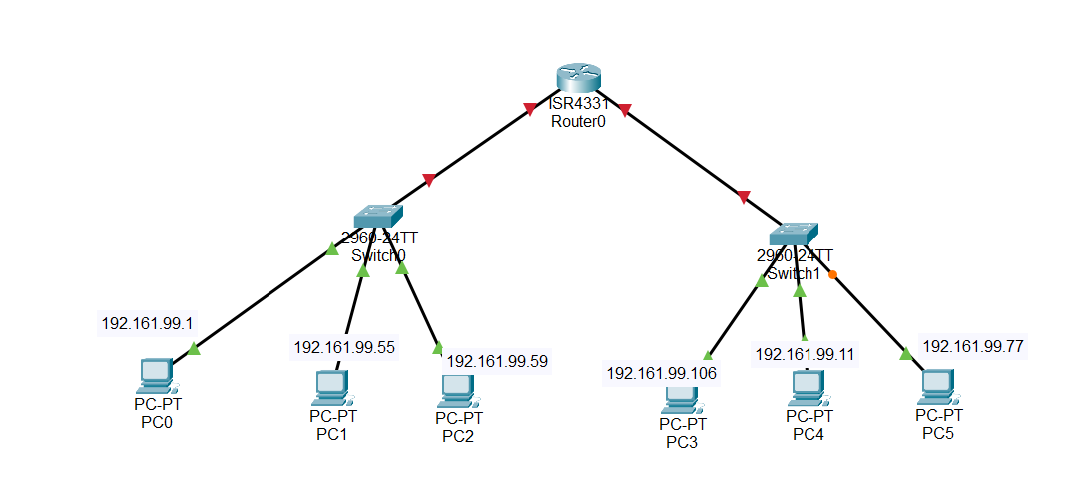

**Output:**

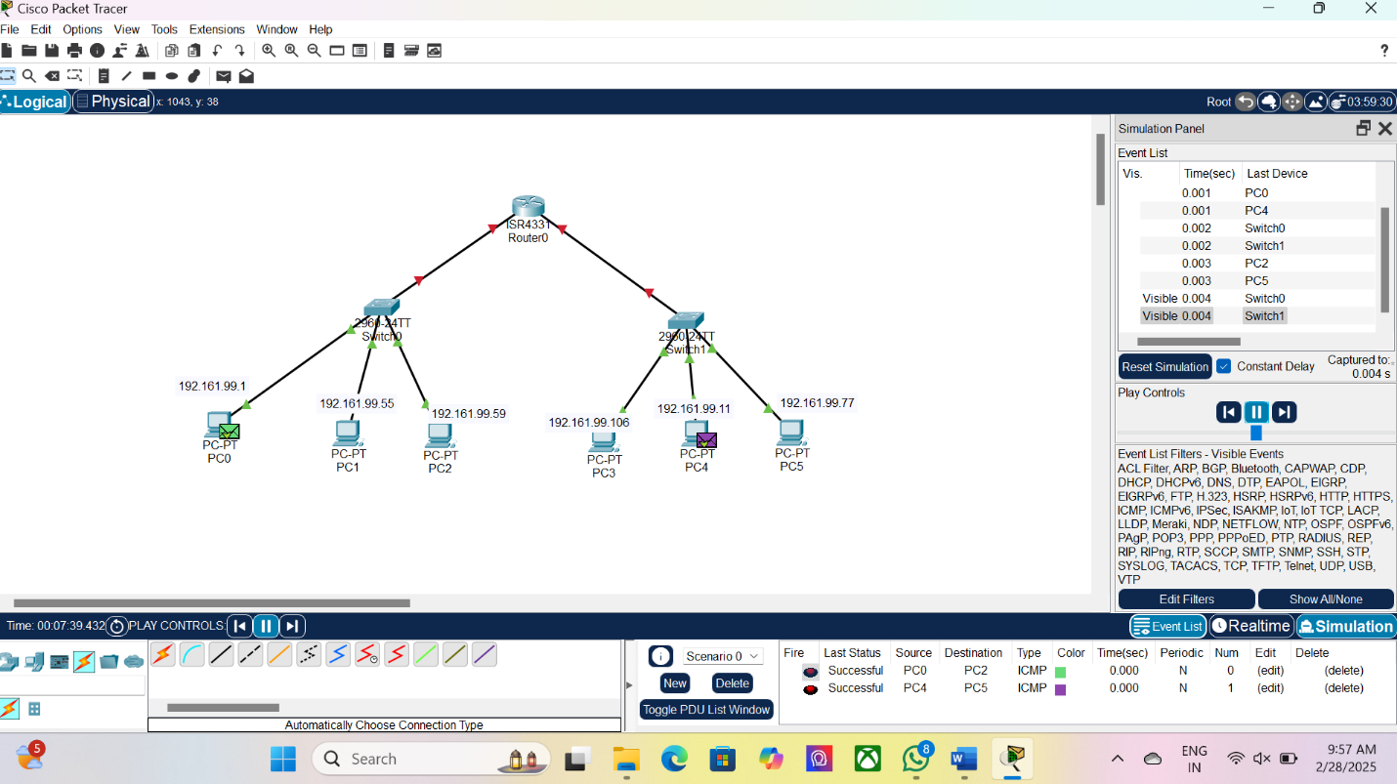

**Result:**

There for designing for network model subnetting has been successfully implemented using packet tracer.